Data set: [Indian Startups Funding](https://docs.google.com/spreadsheets/d/18OpUWH9L2nNGakeW9m_MJ15ubzb9MymDKhKxTLiGHRg/edit?usp=sharing)

Most of the data headers are self explanatory

Basic Formatting:

1. Increase the column widths to appropriate sizes so that they are readable
2. Format the header row in a suitable color
3. Align the header content in middle of the cell
4. Bold the content in headers
5. Draw the borders

Report Making:

1. Freeze the header row
2. Hide unwanted columns

Functions:

1. Add a new column and create a new segment which is combination of Headquarters-Sector EX: Banglore-OTT
2. Add a new column named “Decade” and convert all the years in to decade EX: 1960 - 1969 will be 196
3. Add a new column named “Category” and Print
   1. if Amount > 4500000 and Headquarter is based in any of these cities Bangalore,Pune,Mumbai,Delhi print as CAT A
   2. if Amount > 450000 and Headquarter is based in any of these cities Gurugram,Surat,Jaipur,Hyderabad print as CAT B
   3. Else CAT C
4. Add new column and name it Tier and assign the data according to the Headquarter from Tier

Conditional formatting:

1. Find the duplicates in company column
2. Highlight all series D funding with different color

Sorting and filtering:

1. Sort the decade in ascending order within decade sort the Tier in ascending order and within Tier sort Amount in descending order

Report should look like:

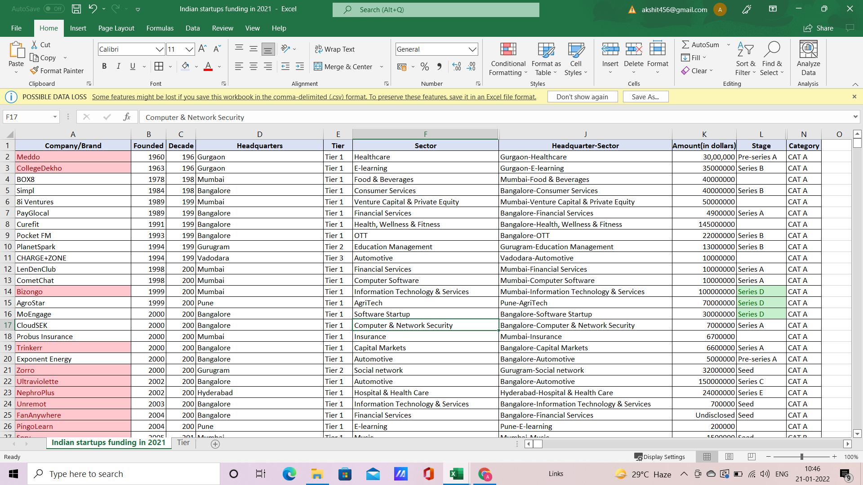

Pivot tables:

1. Create a table for Companies and their total count of fundings and then display sum of amount as their table values
2. Create a Row table for Decade and Tier with Total amount as their table values
3. Create a table for Headquarters and Series with Average amount